
Company
Logotype

Cone Beam Computed Tomography- Report



Porur Dental X-rays & CBCT

Patient Name : Mr. Lakshmi Narayanan | Date of Report : 26.03.2024
Age/ Gender : 57 years/ Male | Region of Interest : CBCT Sectional Mandible
Referring doctor: Dr. Hemachandran | Indication : Implant assessment
Clinical Notes: Nil
PATIENT INFORMATION

CBCT- Sectional Mandible provided
CBCT – IMAGE DETAILS

RADIOGRAPHIC INTERPRETATION

- Complete loss of crown and root structure in relation to 41.
- The alveolar bone in relation to the mandibular ridge is present with normal trabecular pattern.

IMPLANT ASSESSMENT

 | 31 region | 41 region
Sub-Crestal (in mm) | 6.39 | 5.79
Mid- Crestal (in mm) | 6.46 | 6.24
Distance between alveolar ridge and the inferior border of mandible (in mm) | 26.75 | 24.66

RADIOGRAPHIC IMPRESSION

- Partially edentulous region: 41.

Kindly correlate with clinical findings


IMAGES FOR REFERENCE

RECONSTRUCTED PANORAMIC VIEW

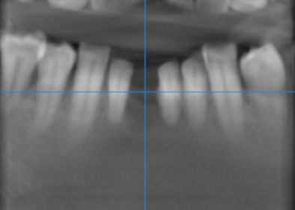

3-DIMENSIONAL VIEW

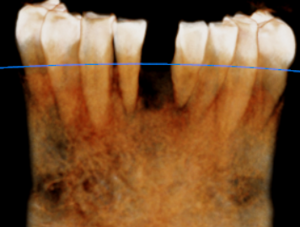

CROSS SECTIONAL VIEW

31 region | 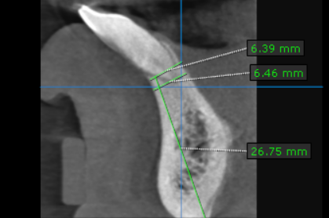
41 region | 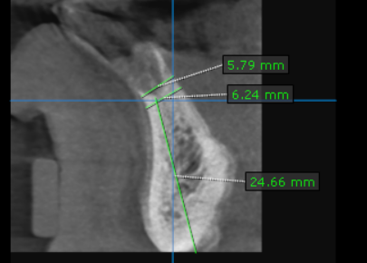

**** End of report ****

